
ADVERSE WEATHER
SITUATION REPORT
As at 3:00pm on 05/05/2023
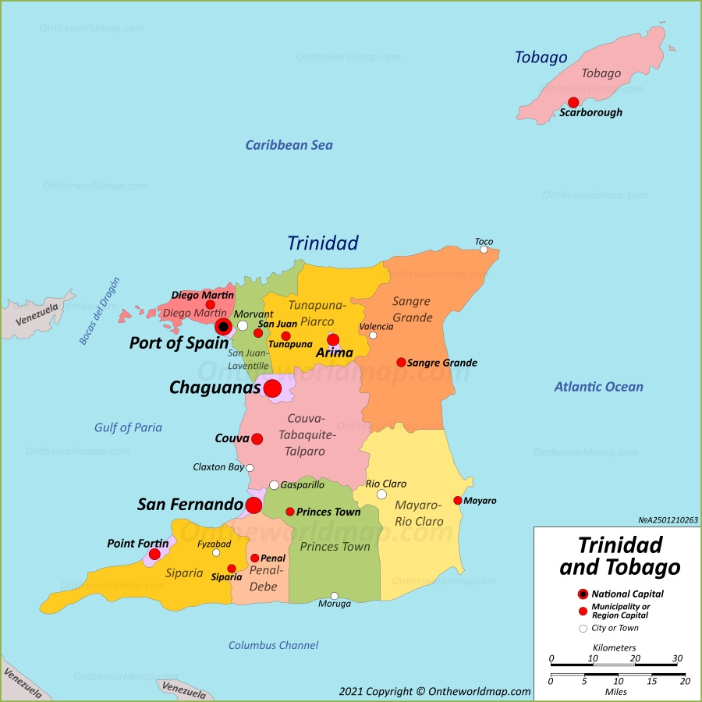
Location:
Ministry of Rural Development and Local Government, Kent House

Present Activity:
Notification Alert

Alert Level:
Adverse Weather Alert #1 - Green Level

Situation Overview:

The Ministry of Rural Development and Local Government has been monitoring a Tropical Wave which left the African west coast on April 30th 2023. At this time, it is located approximately 35 W longitude or 2,889 km east of the Lesser Antilles. Its forward movement is currently 15kt.
The axis of this wave is expected to reach Trinidad and Tobago during the evening of Saturday 6th May 2023.
According to analysis this wave does not appear to be very active as far as convective activity and rainfall amounts are concerned but could still produce some showers and thunderstorms. With the passage of this wave, if it does in fact produce any measurable rainfall amounts, according to TTMS criteria, the 2023 rainy season would be declared for Trinidad and Tobago.

The Ministry of Rural Development and Local Government continues to closely monitor this Tropical Wave and would be keeping you informed.

Penal Debe Regional Corporation

- Informed CEO, Engineer and PMOH
- 200 sandbags available for distribution
- Informed Shelter manager at Barrackpore Regional complex where 20 cots and mattresses are pre positioned
.

Sangre Grande Regional Corporation

- CEO and chairman informed
- Sand prepositioned at vulnerable communities
- Sandbags are also filled from the last event
- Councillors have been called to collect sandbags still waiting on some to collect

Couva / Tabaquite / Talparo Regional Corporation

- Sand and bags are pre-positioned throughout the region. CEO and Chairman to be informed.
- Since no official EW has been issued for the TW, the post from MET would be shared with stakeholders via our various response and CERT chats.
- Once further updates are available via the officials, further actions would follow as per response to previous incidents.

Siparia Regional Corporation

- No reports at this time

San Fernando Regional Corporation

- Informed CEO, Mayor, councillors Heads of Department.
- Alerted CERTs Shelter Managers, wards where prepositioned sandbags stored
- Informed transport for vehicles to fill up gas, have drivers on alert.

Mayaro / Rio Claro Regional Corporation

- DMU informed CEO and Chairman
- Technical Department are informed
- CERT Members were informed yesterday.
- 150 Sand bags filled at the three location
- Response equipment checked

Chaguanas Borough Corporation

- Consultation with CEO/Mayor/based on impending impact
- CORPS that activated the EOC

Diego Martin Regional Corporation

- Informed Chairman of council
- Informed CEO
- Prepacking Sandbags
- Alerting all relevant stakeholders including emergency support personnel
- Inspection of the 15 designated shelters
- Re-check of relief items
- Verification with country Superintendent of functional equipment

San Juan/ Laventille Regional Corporation

- 22 facilities were inspected and recommended as emergency shelters
- 14 emergency shelters have pre-positioned relief items
- CERT members and shelter manager’s personnel have been put on alert and standby
- Additional sand obtained from National Quarries (2 truckloads)
- 530 MT sandbags in stock and 2000 additional are being purchased
- Heads of departments were put on alert and standby
- Conversations with ministry of works and transport T&TEC and TSTT were held and their personnel are on standby for response if needed.
- Distribution of relief items (polythene and tarpaulin) for members of counsel at their selected locations are currently ongoing.
- All communication systems including the hotline and landline numbers, the weather station and VHF radios are operational.

Princes Town Regional Corporation

- Frequently monitor updates from MET.
- No EW Bulletin was issued however the latest MET video was shared to the CEO,
- HODs, Municipal Police, TTFS, Council, Staff, CERT and Shelter Managers of the upcoming event.
- Sandbags are available. Limited relief items on standby.
- DMU will liaise with Technical Dept. to get update on vehicle status. EOC will be activated based on further updates

Arima Borough Corporation
- Filled sandbags approximately 50 at the stockpile. CEO and Chairman notified via WhatsApp
- Information was also shared to the Regional group of Arima for all stakeholders

Port of Spain Regional Corporation
- Currently the DMU has conducted a stock check of our immediate relief items
- Sandbags have been filled and stored at our transport yard location
- Key personnel, CEO and council have been informed about impending weather.
- Key stakeholders and support are being contacted to ensure they are informed of the current weather updates

Point Fortin Regional Corporation
- PFBC... Internal stakeholders and CERTS and Shelter managers made aware of impending weather system

Tunapuna Regional Corporation
- CEO and Disaster committee chair has been informed of present information a request for a backhoe, two dump trucks a flatbed truck
- There is sand, relief items, and 100 mattress received
- Awaiting tarpaulins from A. Moses and sons

Response from the Ministry of Rural Development and Local Government:

A meeting of all Disaster Management Coordinators was scheduled at 1pm where we discussed:
- Inventory
- Activation of Emergency Operation Centre
- Acquiring sand for NGC
- Notification and alert of Municipal staff
- Alerts and notification to CERT Volunteers and Shelter Managers

